Inclusive Voice User Interface (PAS 901:2025)
AI-Driven Multimodal Accessibility for Speech-Impaired and Deafblind Users

1. Overview
Voice User Interfaces (VUIs) have become a primary method of interacting with digital systems such as mobile devices, applications, vehicles, and smart environments. However, most existing VUIs assume that users can speak clearly and hear responses, creating significant accessibility barriers for individuals with speech impairments and deafblind users.
This project presents InclusiveVUI-AI, an AI-agent–based prototype that enables silent, text-based interaction while transparently converting user input into structured system-level commands. The solution demonstrates how AI can act as an intermediary between users and applications/devices, ensuring inclusive access while complying with PAS 901:2025 Vocal Accessibility Standards.

2. Problem Statement (Curated – ACCESS.AI #30)
Traditional Voice User Interfaces are inaccessible to users with speech impairments or combined vision and hearing loss. These systems:
- Depend heavily on spoken input
- Fail to support silent or alternative interaction methods
- Do not handle non-standard speech patterns
- Lack transparent confirmation and fallback mechanisms
As a result, many users are excluded from essential digital services such as mobile applications, workplace tools, and vehicle interfaces.
Objective:
Design an inclusive VUI that supports multimodal interaction, silent input, and generates accessible, system-level commands aligned with PAS 901:2025.
3. Proposed Solution
Solution Name - Inclusive Voice User Interface (InclusiveVUI-AI)
Solution Description
InclusiveVUI-AI is a lightweight AI-agent prototype that:
- Accepts silent text input instead of voice
- Uses AI reasoning to understand user intent
- Converts intent into structured commands consumable by applications, devices, or operating systems
- Provides accessible confirmation using text-first and multimodal feedback
Rather than directly executing actions, the system demonstrates the AI decision pipeline, which is how real-world assistants like Android Voice Access or Google Assistant operate internally.
4. High-Level Architecture

User (Silent Input)

↓
Web UI (HTML/JS)

↓
AI Intent Engine

↓
Structured Command Generator

↓
Application / Device / OS (Simulated)

↓
Accessible Confirmation (Text / Visual / Haptic)

📌 Note:
Execution at OS or device level is simulated to ensure safety and portability.

5. Module Breakdown
5.1 User Interface Module
- Simple web interface for silent input
- Accessible, text-first interaction
- Displays AI reasoning and generated commands transparently
Technology: Python, HTML, JavaScript
5.2 AI Intent Understanding Module
This module simulates how an AI agent interprets natural language input.
It extracts:
- Intent (e.g., Vehicle Control, Application Control)
- Action (e.g., STOP, OPEN_APPLICATION)
- Urgency (NORMAL / HIGH)
This mirrors how enterprise AI systems structure user intent internally.

5.3 System Command Generation Module
The interpreted intent is converted into a structured system command, similar to how assistants communicate with operating systems or devices.
Example command structure:
{
"protocol": "INCLUSIVE-VUI",
"target_system": "VEHICLE_CONTROL",
"command": "STOP",
"priority": "HIGH",
"confirmation_required": true,
"output_modalities": ["text", "haptic", "visual"]
}
This abstraction allows easy integration with:
- Mobile OS APIs
- Automotive systems
- Assistive applications

5.4 Accessibility & Confirmation Module
Ensures:
- Explicit confirmation of actions
- Text-first feedback
- Support for multiple output modalities
This directly aligns with PAS 901:2025 principles.

6. PAS 901:2025 Compliance Mapping
PAS 901 Principle | Implementation in InclusiveVUI-AI
Multimodal Interaction | Silent text input and visual feedback
Non-standard Speech Support | No dependency on spoken input
Fallback Mechanisms | Text-first confirmation
Transparency | Visible AI intent and command generation
User Confirmation | Mandatory confirmation for actions

7. Sample Code Snippet (Reference)
Backend.py
from flask import Flask, request, jsonify, render_template

app = Flask(__name__)

@app.route("/")
def home():
return render_template("index.html")

def ai_intent_engine(user_input: str):
"""
Simulated AI intent extraction layer.
This represents what an LLM would produce internally.
"""

text = user_input.lower()

# Default intent structure
intent = {
"intent": "GENERAL_ASSISTANCE",
"action": "INTERPRET_REQUEST",
"urgency": "NORMAL"
}

# Vehicle-related intent
if any(word in text for word in ["vehicle", "car", "drive", "stop", "brake"]):
intent = {
"intent": "VEHICLE_CONTROL",
"action": "STOP",
"urgency": "HIGH"
}

# Application-related intent
elif any(word in text for word in ["open", "launch", "start"]):
intent = {
"intent": "APPLICATION_CONTROL",
"action": "OPEN_APPLICATION",
"urgency": "NORMAL"
}

# Assistance intent
elif any(word in text for word in ["help", "assist", "support"]):
intent = {
"intent": "USER_ASSISTANCE",
"action": "PROVIDE_GUIDANCE",
"urgency": "NORMAL"
}

return intent

def ai_system_command(intent_data):
"""
Converts AI intent into a system/device command.
This simulates OS / device-level integration.
"""

return {
"protocol": "INCLUSIVE-VUI",
"target_system": intent_data["intent"],
"command": intent_data["action"],
"priority": intent_data["urgency"],
"confirmation_required": True,
"output_modalities": ["text", "haptic", "visual"]
}

@app.route("/process", methods=["POST"])
def process_input():
data = request.get_json()
user_input = data.get("input", "").strip()

# AI reasoning layers
ai_intent = ai_intent_engine(user_input)
ai_command = ai_system_command(ai_intent)

return jsonify({
"user_input": user_input,
"ai_intent_model": ai_intent,
"ai_system_command": ai_command
})

if __name__ == "__main__":
app.run(debug=True)

index.html
<!DOCTYPE html>
<html>
<head>
<title>Inclusive Voice User Interface (PAS 901:2025)</title>
<meta charset="UTF-8">
</head>
<body>

<h2>Inclusive Voice User Interface (PAS 901:2025)</h2>

<p>
This prototype demonstrates how silent user input is transformed by an AI agent
into structured system commands that can be executed by applications, devices,
or operating systems.
</p>

<label><strong>Enter Silent Input:</strong></label><br><br>

<input id="input" type="text" style="width:360px;">
<button onclick="send()">Submit</button>

<hr>

<p><strong>User Input:</strong></p>
<pre id="userInput"></pre>

<p><strong>AI Understanding (Intent Model):</strong></p>
<pre id="aiIntent"></pre>

<p><strong>AI → System / Device Command:</strong></p>
<pre id="aiCommand"></pre>

<script>
function send() {
fetch("/process", {
method: "POST",
headers: { "Content-Type": "application/json" },
body: JSON.stringify({
input: document.getElementById("input").value
})
})
.then(res => res.json())
.then(data => {
document.getElementById("userInput").innerText =
JSON.stringify(data.user_input, null, 2);

document.getElementById("aiIntent").innerText =
JSON.stringify(data.ai_intent_model, null, 2);

document.getElementById("aiCommand").innerText =
JSON.stringify(data.ai_system_command, null, 2);
});
}
</script>

</body>
</html>

📌 Note:
In production, this logic can be replaced with an enterprise Large Language Model (LLM).

8. Screenshots
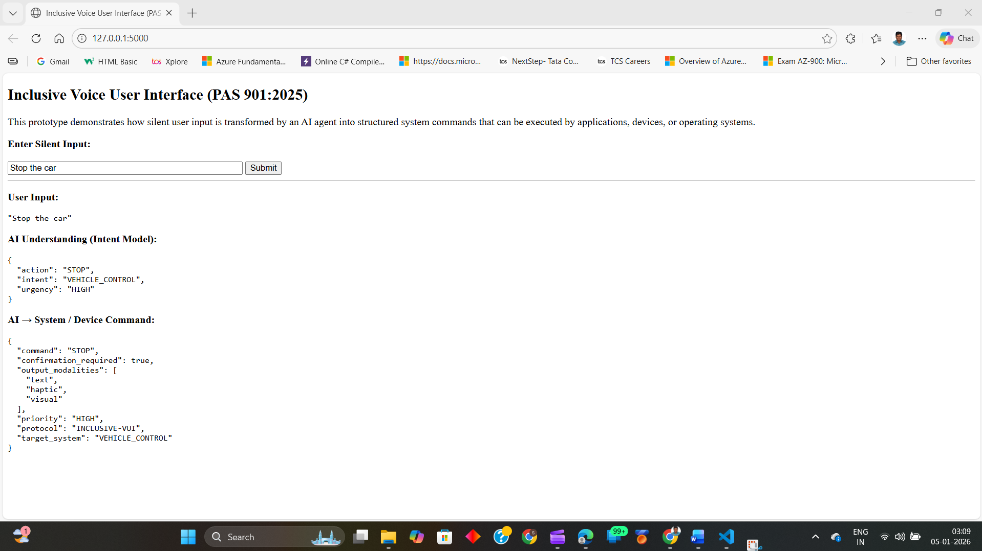
Application UI with silent input
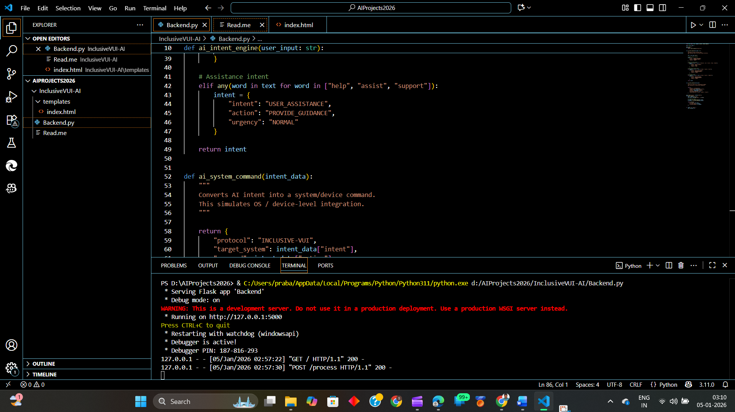
Backend running (Flask server)
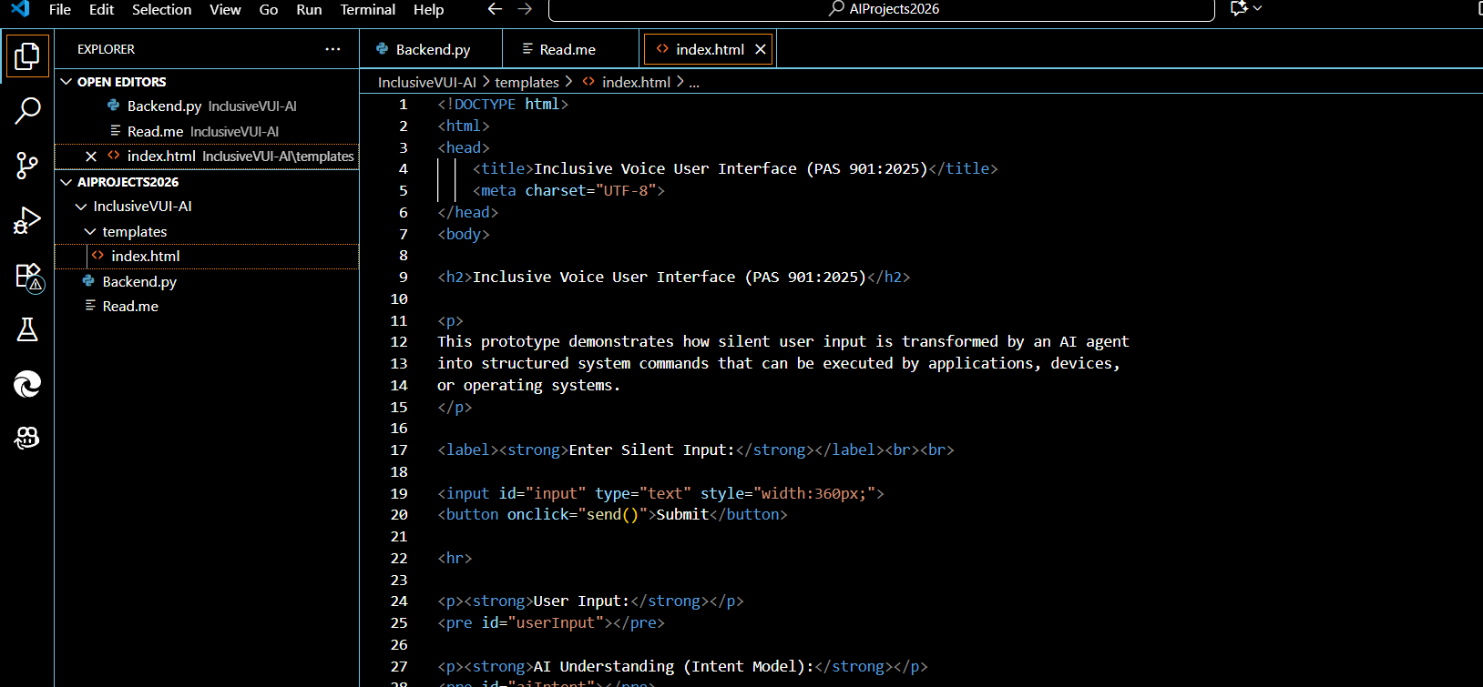
Code structure in IDE
9. Scope & Limitations
- This prototype focuses on AI decision-making and accessibility design, not direct device execution
- OS-level and hardware integrations are simulated
- Designed for safe, scalable, and cross-platform extension

10. Future Enhancements
- Integrate real LLMs (Azure OpenAI / enterprise models)
- Connect to Android Accessibility APIs
- Support voice, haptic, and Braille outputs
- Add multilingual and context-aware reasoning

11. Conclusion
InclusiveVUI-AI demonstrates how an AI-agent–driven approach can transform silent user input into structured, system-level commands while maintaining transparency, accessibility, and safety. By aligning with PAS 901:2025, the solution shows a practical path toward inclusive Voice User Interfaces that empower users with speech impairments and deafblind users to interact independently with modern digital systems.

